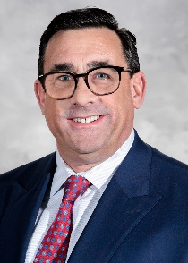

Edward McGookin, MD, MHCDS, FAAP, is the President of Coastal Medical. Coastal provides care to over 155,000 patients in 23 medical offices across Rhode Island and is at the forefront of work on healthcare delivery system transformation and payment reform both locally and nationally.

Dr. McGookin practiced general pediatrics for more than 15 years at Coastal Waterman Pediatrics before he assumed the role of Chief Medical Office at Coastal in 2012. In that role, he developed population health management initiatives at Coastal. This included diabetes, COPD, heart failure, and hypertension management programs, the Coastal@Home program for frail elderly patients, an Integrated Behavioral Health, and a Musculoskeletal Health program. He assumed the role of President of Coastal in 2022 and is committed to expanding the quality and range of services provided through population health management to more patients and primary care practices.

Dr. McGookin received his MD from the State University of New York Health Science Center, Syracuse, NY. He did his residency training in Pediatrics at Hasbro Children’s Hospital in Providence, RI, and completed a master’s degree in Health Care Delivery Science at Dartmouth College in 2018. Dr. McGookin holds an appointment as an Associate Clinical Professor of Pediatrics at the Warren Alpert Medical School of Brown University.

